4.6 Enriching data (new columns and tables)

Key points

Dataflow Gen2:
In a Dataflow Gen2, there are a number of methods for adding a column to your query:
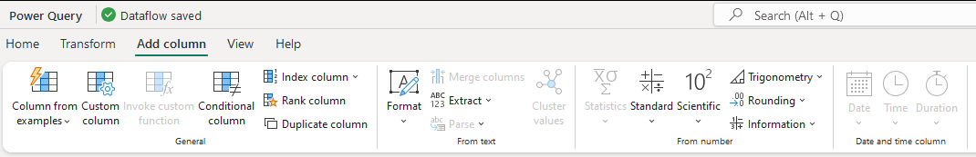
- Column from examples - allows you to give some expected values, and the Dataflow will try to guess the pattern, and generate your M query that outputs your expected values.

- Custom Column - you can write Power Query formulas to create the logic you need for your new column

- Conditional columns - allow you to write conditional logic to define your new column. For example, if the column value is greater than, or equal to x, the output value should be y.

In a Data Warehouse:
- You can add columns to a dataset, simply by declaring them in a SELECT statement. For example
SELECT [customer_id]
,[customer_name]
,[customer_city_id]
,[customer_email]
, 'HubSpot' as [source_system]
, YEAR(GETDATE()) as [current_year]
FROM [DW001_DWH].[raw].[hubspot_contacts]
- this query adds a constant value of 'HubSpot' to the [source_system] column, and the [current_year] column as a Calculated column.

- In this example, you can use a CASE statement to define a new column with conditional logic:
SELECT [customer_id]
,[customer_name]
,[customer_city_id]
,[customer_email]
, 'HubSpot' as [source_system]
, CASE WHEN [customer_id] <= 10 THEN 'GOLD'
WHEN [customer_id] <= 20 THEN 'SILVER'
WHEN [customer_id] <= 30 THEN 'BRONZE'
ELSE 'No Prize'
END AS 'promotion_category'
FROM [DW001_DWH].[raw].[hubspot_contacts]

